Why is hand hygiene important?

To prevent the spread of hospital infections
Following admission to Irish hospitals, approximately 1 in 20 patients acquire an infection. Infections acquired/picked up in hospitals can be harder to treat. You can help protect yourself by asking staff and visitors to clean their hands.

To make a difference in your own health
Hand hygiene is one of the most important ways to prevent the spread of infections, including the common cold, flu and even hard-to-treat infections such as MRSA.

REMEMBER: HAND HYGIENE SAVES LIVES

Who should carry out hand hygiene?
Patients and visitors should clean their hands regularly. Healthcare staff also know they should clean their hands before and after touching patients, but sometimes forget. It’s OK to ask them to clean their hands. It only takes a few simple words to help encourage this healthy habit “Excuse me, did you clean your hands?” or “I saw that you cleaned your hands, thank you” Encourage children to wash their hands by showing them how to do it, and by setting them a good example.

When should I carry out hand hygiene?
Patients: You should carry out hand hygiene when your hands are visibly dirty and
- before preparing or eating food
- before touching your eyes, nose or mouth
- After tasks that might lead to exposure to body fluids, such as emptying your urinary catheter
- after using the toilet, bedpan or commode
- after blowing your nose, coughing or sneezing

Visitors: should carry out hand hygiene
- on arrival to the hospital
- before and after visiting their relative/friend

Staff: should carry out hand hygiene
- Before and after touching you
- Before performing a clean/aseptic technique such as touching a medical device or dressing
- Before and after touching dressings or medical devices (e.g. drips, catheters)
- After touching things in your area, such as bed rails, bed trolley etc.
- Before and after removing gloves

REMEMBER: ASK YOUR HEALTHCARE PROVIDER TO CLEAN THEIR HANDS BEFORE THEY EXAMINE YOU

How do I carry out hand hygiene?
With soap and water:
- Use soap and water when your hands look dirty.
- If you are wearing a ring, it is important to wash underneath it.
- Sleeves to be rolled up to expose wrists.
- Follow steps for 40-60 seconds in leaflet/wall signage beside sink.
With alcohol gel or rub:
- Alcohol gel or rub to be used for hand hygiene when your hands look clean.
- Follow directions on the bottle/wall signage for how much of the product to use.
- Rub hands together following steps 3-9 in leaflet/wall signage beside gel dispenser for 30 seconds until hands are dry.
- You should not rinse your hands with water or dry them with a towel.

REMEMBER: IT ONLY TAKES 40-60 SECONDS TO PROTECT YOURSELF AND OTHERS

What hand hygiene product should I use?
Use soap and water:
- When your hands look dirty
- After you use the bathroom
- Before you eat
- Follow ward staff instructions as soap and water are better at removing some germs that cause infections (e.g. Clostridium difficile)
Use an alcohol-based hand rub or gel:
- When your hands look clean
- If soap and water are not available
Use detergent hand wipes, alcohol gel or request a bowl of water and soap:
- When you are unable to access a sink after using the toilet, commode or bedpan.
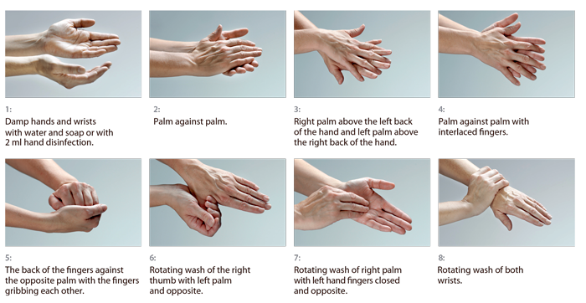

Further information: Talk to a member of the staff or the ward/department manager / Infection prevention and control in the hospital / www.hpsc.ie

