**The procedure for collecting nasal and throat swabs for investigation of respiratory viruses including COVID-19.**

* Explain procedure to the patient
* Collect **both nasal and throat swab** using the one swab
* Insert swab into patients open mouth
* The swab is used first to abrade the tonsils and pharynx (see diagram below on right). This will induce a gag reflex.
* This swab is then inserted into the nostril and rubbed against and above the nasal turbinate. (swab to be advanced almost 4 inches into the nostril. This will bring a tear to the eye)
* Repeat for the other nostril.
* P**lace the swab into the red container** containing the transport medium**.**
* Break off the swab at the moulded breakpoint on the swab shaft (see picture below on the left)
* **Close lid securely.** Ensure that the bottle lid is secured tightly onto the bottle to prevent leakages.
* **Label specimen** for COVID19 PCR and write on clinical details if patient is symptomatic.
* Can be sent in POD system (clean POD inside and outside with 70% Alcohol wipe before sending)

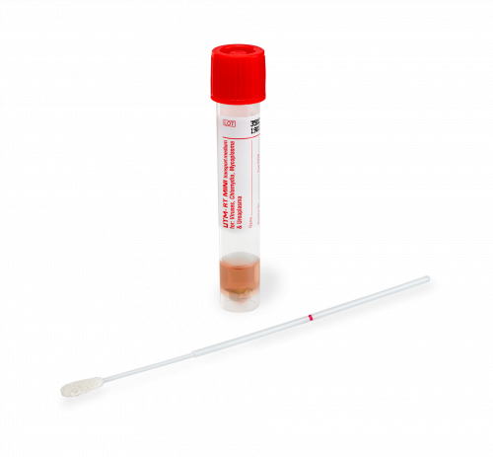

Break swab here