Laboratory Investigation for SARS-CoV-2 (COVID-19)
There are 2 main types of tests for COVID-19, which have different benefits and limitations, depending on the phase of infection. No test is 100% sensitive or 100% specific.
COVID-19 tests:
- Detection of pathogen by PCR-based SARS-CoV-2 RNA detection.
  - This test is performed on a sample from the respiratory tract (swab)
  - Diagnosis of acute infection
- Detection of SARS-CoV-2- specific antibodies to the infecting virus, after the immune system has developed a response.
  - This test is performed on a sample of blood
  - Diagnosis of past infection

Pathogen detection tests (such as PCR) and tests to detect an immune response to the virus (development of SARS-CoV-2-specific antibodies) should not be considered competing alternatives. Both testing approaches are clinically relevant, but must be deployed at different time points during the clinical course of infection taking consideration of their relevant diagnostic windows (Figure 1).

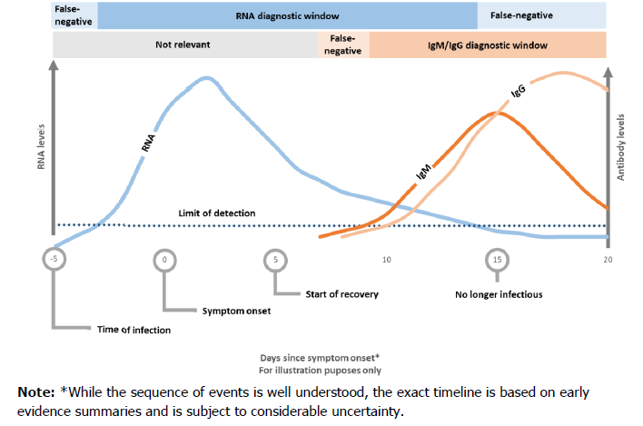
Figure 1: Diagnostic windows for the detection of acute SARS-CoV-2 infection (viral RNA) and the immune response (anti-SARS-CoV-2 IgM and IgG) indicating past exposure to SARS-CoV-2²

Diagnosis of Acute Infection (PCR):
PCR is the ‘gold standard’ recommended for the diagnosis of COVID-19 during the acute phase of infection.
False negative results can occur if testing takes place in the initial incubation period following infection. The minimum duration from infection to a positive test remains uncertain. SARS-CoV-2 viral RNA can be detected one-to-two days prior to symptom onset in upper respiratory tract samples (Figure 1). Based on limited early data, viral load peaks around the time of symptom onset, the level of virus in nasopharyngeal secretions declines progressively over time after onset of symptoms becoming undetectable approximately two weeks following symptom onset.

The diagnostic window for using PCR to detect acute infection with SARS-CoV-2 therefore ranges from approximately three days following exposure to the virus until two weeks following symptom onset (Figure 1).

Testing in BSHC is performed using one of the following assays:
- GeneXpert (testing performed in house in BSHC)
- Primerdesign (testing performed in conjunction with Animal Health Laboratories, Bandon)

Interpretation of PCR results:
When SARS-CoV-2 is DETECTED, this indicates that virus is present.
Note: Viral RNA may be detected for a period when replicating virus is no longer present. Detection of virus RNA does not necessarily mean that the person is infectious.

When SARS-CoV-2 is NOT DETECTED, in a well taken sample during the symptomatic period this makes it much less likely that the person has COVID-19. However in some people with symptomatic infection virus has been undetectable in nasopharyngeal samples swabs.
Note: A negative PCR result is only an indication of the patient’s status at a point in time. If self-isolation is required from a public health perspective, a negative result does not negate the need for self-isolation.

Diagnosis of prior infection (Antibody Testing/Serology):
PCR cannot be used to identify past exposure to SARS-CoV-2. To identify those who have been exposed to SARS-CoV-2, tests that detect antibodies (IgM and IgG) produced by the body in response to SARS-CoV-2 infection can be used. Antibodies are typically detectable 7-to-14 days (a week to a fortnight) after the onset of symptoms. (Figure 1)

BSHC Pathology offer the Abbott Architect SARS CoV-2 IgG Antibody Assay (note IgG only, IgM not currently available). Studies on this assay suggest that if a patient has COVID-19 and has this test >14 days after symptom onset then the test will be positive in 100% of cases. If the patient has not had COVID-19, then the test will be negative in 99.63% of cases. As there is no gold standard, we cannot state sensitivity and specificity but the above figures provide a good guide. Based on experience with other high impact coronaviruses, it is likely that antibody will wane rapidly over time, and therefore the result only reflects SARS-CoV-2 antibody at this point in time.
Antibody tests can indicate if there is evidence of likely prior infection with the virus. At present we do not have sufficient evidence to use tests for antibody to SARS-CoV-2 to:
- Exclude acute or past infection
- Provide information about whether the patient remains infectious
- Indicate protective immunity to re-infection

There is evidence to indicate that some individuals do not develop antibody to SARS-CoV-2 despite the presence of symptoms compatible with COVID-19 or the detection of SARS-CoV-2 RNA. This is likely to be a reflection of the limited antibody response which develops in some individuals rather than a failure of the test to detect antibodies. Results will therefore be reported as DETECTED or NOT DETECTED.

Pre-Test Consultation
- Patients should not be tested without being informed about the limitations of either test.
- Patients must be informed that current evidence does not indicate whether antibodies correlate with protection, so they must undertake to continue to observe public health advice.
- At the moment whatever the result of the COVID test the safest thing to do is to continue to follow all public health advice and if you are a healthcare worker to follow all the Infection Prevention and Control and Occupational Health advice.
- A negative test result is only an indication of the patient’s status at a point in time. If self-isolation is required from a public health perspective, a negative result does not negate the need for self-isolation.

