s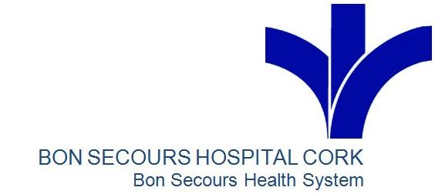

GP Referral Guidelines for Private Covid Swabbing Bons Secours Hospital Cork
&
Pre-Travel Related COVID-19 Testing (to Countries requiring a Negative COVID-19 Report)
Step 1: GP Referral
We now accept GP referrals for COVID-19 testing for both symptomatic and asymptomatic patients at BSHC.
Please send all referrals via Healthlink & Please Provide Out of Hours Contact Details on the form so Covid positives can be dealt with in a timely manner
If a test is travel related, can you please ensure that at least 5 days notice (prior to travel date) is given. Please be aware of the travel date and the timing of the swab and that it is included in the referral.
The Gov.ie website has the recommendation around people travelling into Ireland.
https://www.gov.ie/en/publication/b4020-travelling-to-ireland-during-the-covid-19-pandemic
Step 2: Appointment Time & Cost
The Swabbing Clinic will contact the patient with an appointment time to attend for swabbing for COVID-19. The appointment will be scheduled 48-72 hours prior to travel, pending on requirements. All other Covid requests will be facilitated in a timely manner, as appropriate.
The Swabbing Clinic is run daily Mon-Friday for GP Referrals. The Cost of the swab is €140 payable by credit card only at the time of the patient’s confirmation of appointment
Step 3: Attending the Swabbing Clinic
Our swabbing clinic is located at the Western Road entrance, on the first left as they are facing the new bridge. Please note that this is a drive through clinic and we will ask patients to remain in your car. A swab from your throat & your nose will be taken.

Step 4:
Results: Will be provided within 48 Hours from when the patient is tested. However please note that if the test is after 1pm on a Friday, this sample will be processed on Sunday and the patient will receive the result by the Monday.
If the swab is Negative – the patient will receive a text message and the result will go directly to the GP. If a printed copy is required for travel purposes this can be collected at the Hospital’s main reception by requesting this at the time of booking the swab or afterwards by calling 021 4801720. Pathology Office hours are 09.00-17.00 Monday to Friday. Patients are asked to pick up results at the appointed time and not before.
If the test is Positive
The GP will be contacted by the Consultant Microbiologist but, if not available, the patient will be contacted directly. In addition, the Health Protection Authority will receive notification and all the patient contacts will be followed up appropriately
Information regarding self isolation can be found on the hpsc.ie website
https://www.hpsc.ie/a-z/respiratory/coronavirus/novelcoronavirus/guidance/selfisolationathome/
If a patient require further information call the following numbers:
HSE COVID Helpline on 1850241850 or Public Health 0214927601
For Further Information please See Link on Bons Website:
https://www.bonsecours.ie/gp-covid-19-lab-investigation-information-
or contact Karina Healy 0861451069

